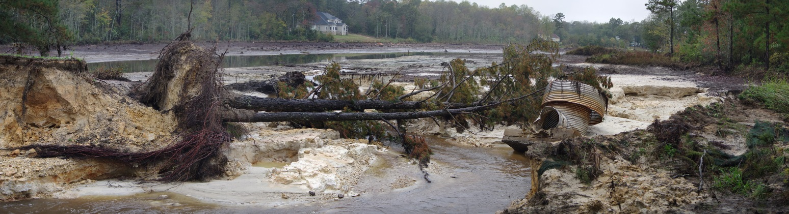
As the Waters Recede, Richland County’s Disaster Recovery Process Rises Above
On September 27, 2015, Hurricane Joaquin developed over the Atlantic Ocean and within days became one of the largest hurricanes to affect South Carolina. Although Hurricane Joaquin did not make landfall in South Carolina, it brought historic rainfall over a five-day period. Approximately 16.6 inches of rain fell within 10 hours, causing catastrophic flooding and inundation of the local dams and creeks within Richland County (County). The unprecedented rainfall and resulting 1,000-year flood event caused 19 dams to fail; damaged or destroyed thousands of homes, businesses, and infrastructure; and impaired the local economy. As a result, the president issued a major disaster declaration (DR 4241) on October 5, 2015.
Although the County had never experienced a disaster of this magnitude, County staff quickly jumped into action to respond to, recover from, and take measures to mitigate future disasters. Prior to the hurricane making landfall, the County proactively opened its emergency operations center. County staff and first responders worked swiftly and effectively to protect lives, property, and the environment. The County provided life safety services, including rescue, sheltering, and mass care and feeding operations. In the wake of this historic event, the County now faced the daunting task of recovering from an unprecedented amount of damage.
The County selected Mike King to serve as the Local Disaster Recovery Manager. The County also hired Tetra Tech, Inc., a consulting firm with significant disaster response and recovery expertise, to help guide the County through the recovery process. The Richland County Council issued a guiding directive to Mr. King and Tetra Tech: Ensure no resident drops through the cracks.
Mr. King’s first major action was facilitating the development of a Recovery Plan with a Recovery Concept of Operations to help the County focus on reaching the desired recovery end state.
Figure 1: Richland County Recovery Concept of Operations
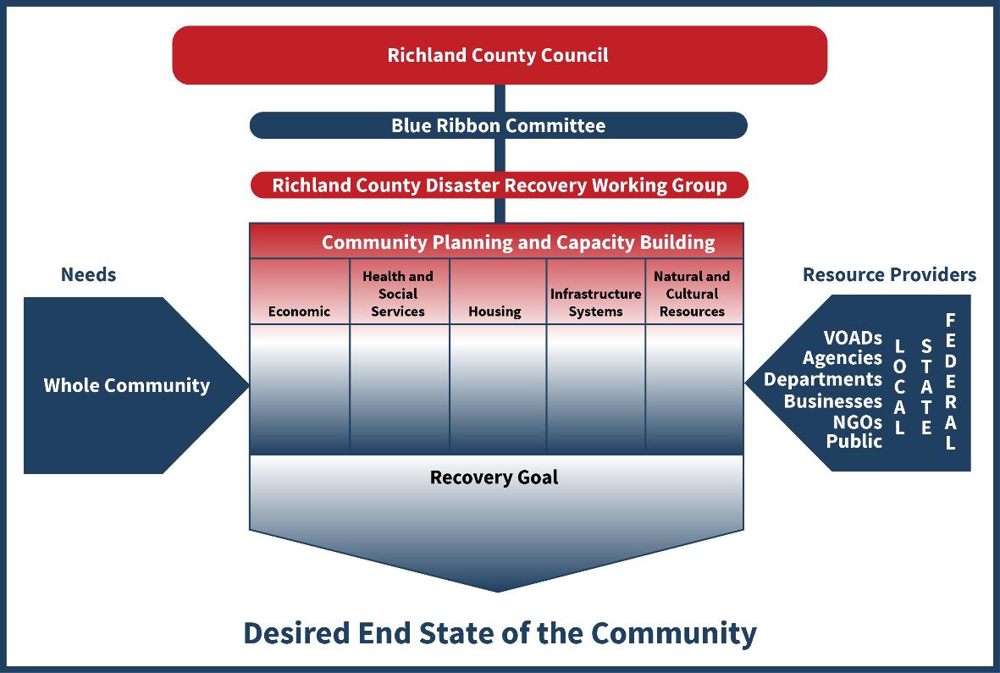

Richland County’s Recovery Concept of Operations was developed following the National Disaster Recovery Framework. The Richland County Council is the duly elected body that oversees all governmental activities in Richland County, including recovery operations. The Richland County Council formed a Blue Ribbon Committee to provide recovery-related recommendations, oversee the development of the Richland County Long-Term Recovery Plan, and provide policy guidance and direction to the Local Disaster Recovery Manager and the Richland County Disaster Recovery Working Group on all recovery-related matters.
WHAT DO OTHERS HAVE TO SAY
“The Richland County Emergency Management Services Division utilized the grant-funded staff to provide a safety net to its citizens to ensure they receive the recovery services they needed.”
--Tammy Beagen
Midlands Workforce Development Board

"I’m constantly impressed how involved and helpful members of the Richland County team have been during the Midland’s storm recovery. They continue to help SBP and other volunteer organization when we need the support of the community."
--Michela Schildts
SBP SC Operations Manager

“The way Richland County handled needs assessments, public outreach, VOAD collaboration, and recovery concept of operations development sets new standards of excellence in recovery operations. Other jurisdictions in Southern Georgia and throughout the nation—including Washington, D.C.; Houston, Texas; and the State of Hawaii—have looked to Richland County’s recovery work as a model for best practices.”
--Jonathan Burgiel
Tetra Tech

Of all the organizations with a role in Richland County’s Recovery Concept of Operations, the Blue Ribbon Committee has the most pivotal role in the success of Richland County’s recovery efforts. The Blue Ribbon Committee is composed of Richland County Council members; elected officials from local jurisdictions; local leaders representing disadvantaged communities; representatives from environmental groups, faith-based organizations, the United Way, and key volunteer organizations; and representatives from state and federal agencies. The Blue Ribbon Committee acted as the voice of the community affected by this disaster and worked to ensure that the public’s need—especially the disadvantaged population’s needs—remained foremost in the minds of Richland County staff. The Blue Ribbon Committee provided guidance and direction to the Richland County Disaster Recovery Working Group and the Local Disaster Recovery Manager and provided key policy recommendations to the County Council.
The Richland County Disaster Recovery Working Group is composed of key County staff and stakeholders from key private entities when applicable. The Richland County Disaster Recovery Working Group makes recommendations to the Blue Ribbon Committee on the Hazard Mitigation Grant Program (HMGP) and Community Development Block Grant-Disaster Recovery (CDBG-DR) priorities and on resolving unmet needs by reviewing each case and assigning resources ideally suited to address each unmet need.
Identifying Unmet Needs. When the U.S. Department of Housing and Urban Development (HUD) approved the Richland County CDBG-DR Action Plan, the agency specifically commended the County on the strength of its documentation of storm-related unmet needs. Mr. King used the National Emergency Grant-Disaster Recovery funds that the U.S. Department of Labor offered through the State of South Carolina to local jurisdictions to hire two disaster recovery specialists. The County used these specialists to conduct a concentrated public outreach effort resulting in an estimate of over $251 million in unmet recovery needs, of which, over $194 million are estimated home repair needs. The County used this estimate to receive a direct allocation from HUD of over $23.5 million to help low- to moderate-income residents recover from the disaster.
Matching Resources to Unmet Needs. The County has yet to receive HMGP or HUD federal dollars for repairs from the flood. This is not unusual; it normally takes years to receive federal funds after the disaster. However, the County has developed strong partnerships with the MFRG and the VOADs to help bridge the gap until the federal dollars are disbursed. To date, the MFRG and the VOADs have repaired or rebuilt 100 storm-damaged homes. Working through the MFRG, we anticipate our VOAD partners will repair or rebuild another 150 homes before the recovery is complete.
Richland County leveraged as many federal recovery grant programs as possible. Like a solving a complex puzzle, the County was able to piece together a cohesive recovery using programs that complemented one another. The County sought federal HMGP funds through FEMA, CDBG-DR funds through HUD, and Natural Resources Conservation Services (NRCS) funds through the United States Department of Agriculture (USDA). “The County has been a critical partner with United Way and the long-term flood recovery process. The County has demonstrated a deep commitment to its residents with outreach and a transparent process in allocating disaster recovery federal funding streams,” said Jennifer Moore, with United Way of the Midlands. Mr. Robert Burton, South Carolina Hazard Mitigation Officer, also stated that the County has been “diligent to its citizens.”
Impact. Rebuilding a community after a disaster of historic proportions is a long and arduous road. It takes the whole community working together to help all of us recover. That said, Richland County has developed a Recovery Concept of Operations that can be considered a national best practice. Richland County’s Recovery Concept of Operations allows the voices of the public, especially those most disadvantaged, to be heard by the County government through the Blue Ribbon Committee and its extensive public outreach efforts. In addition, to help meet the unmet needs of its residents, Richland County has developed and leveraged relationships with the MFRG under the direction of United Way and the VOADs to help its most vulnerable residents begin to recover while awaiting federal funds. Finally, Richland County is leveraging and coordinating a number of federal grant programs to help its most vulnerable citizens recover from the damage caused by this devastating storm.
Although the County will never be the same after such a catastrophic event, we can lessen the impacts of future disasters by identifying vulnerabilities and increasing our resiliency to such incidents.
For more information about the County’s disaster recovery process, please visit www.rcgov.us/floodrecovery.com.

